**Definition: Use fill Stroke &amp; Advanced Stroke Properties in your design.**

**Solution:**

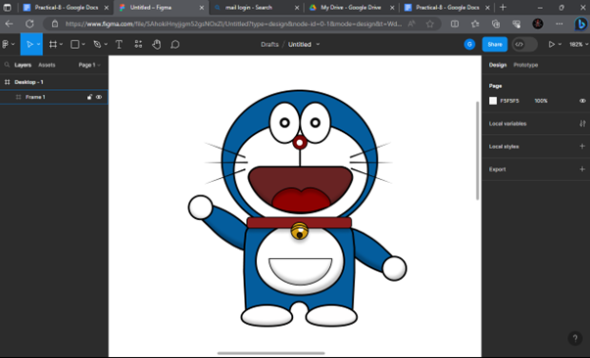

**Steps:**

* First Open Figma in browser mode.
* Then create the new document **File à New Figma Design.**
* Take a Frame.
* Take an ellipse for the head and fill Color & stroke into ellipse. Color: “#**045D9D”**, Stroke: “**2”**
* Take another ellipse for eyes and fill the Color & stroke into the ellipse. Color: “#**FFFFFF”**, Stroke: “**3”**
* Take one more ellipse for the nose and fill the Color & stroke into the ellipse. Color: “**#7A0707**”, Stroke: “**1”**
* Take another ellipse for the mouth and fill Color & stroke. Color: “#**682323”**, Stroke: “**2”**
* Then after, use a rectangle tool for the neck belt and use stroke & fill Color: “#**8A1C1C”**, Stroke: ”**1”**
* Then take a rectangle for the body of the Doraemon. Color: “#**045D9D”**, Stroke: “**2”**
* Draw the circle for the stomach using an ellipse tool. Color: “#**FFFFFF”**, Stroke: “**2”**
* Draw the magic pocket using an ellipse tool. Color: "#**FFFFFF”**, Stroke: “**1”**
* Take another rectangle & ellipse tool to draw the hand of the Doraemon.
* Then fill the Color and stroke in the shapes. Color: “#**045D9D”**, Stroke: “**2”**
* At last, take an ellipse to draw the leg and fill Color & stroke.Color: “#**FFFFFF”**, Stroke: “**2”.**
* Now, Go to the **Export** button in the property panel. And **Export** it with .**JPG/.PNG** format.